Lab 11: Object-Relational Features in Oracle
Date: __/__/2025

OBJECTIVES:
1. To understand Object Types and Object Tables in Oracle
2. To implement member methods and MAP functions in object types
3. To work with REF data types and object references
4. To demonstrate DEREF operations and dangling references
5. To understand object-relational modeling concepts

THEORY OVERVIEW:
Oracle Object-Relational features allow users to define custom data types
with attributes and methods. These object types can be stored in tables,
referenced using REF, and manipulated using object-oriented concepts such
as encapsulation and method invocation.
1.1 Object type with method
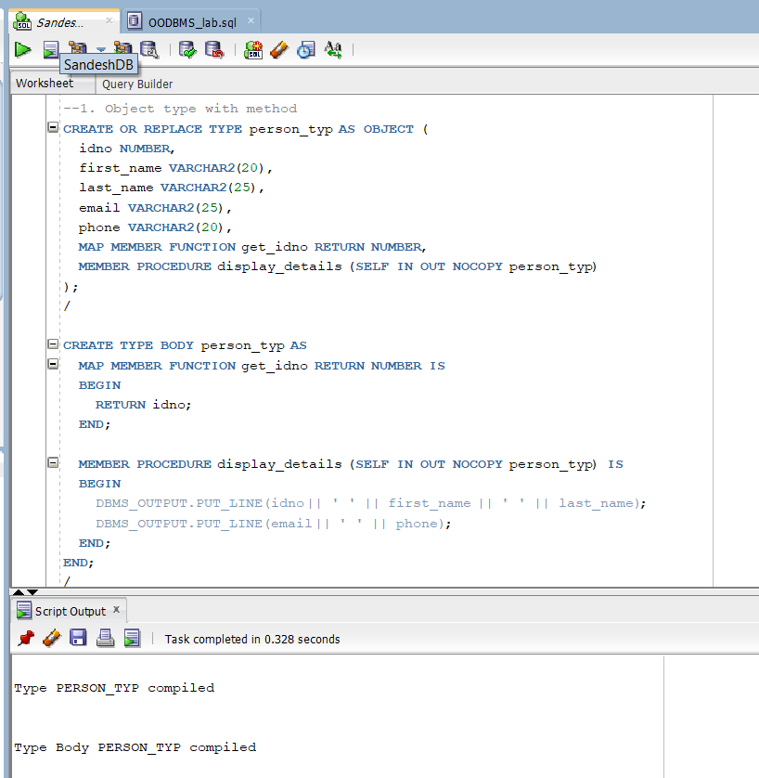

1.2. Table with Object Column
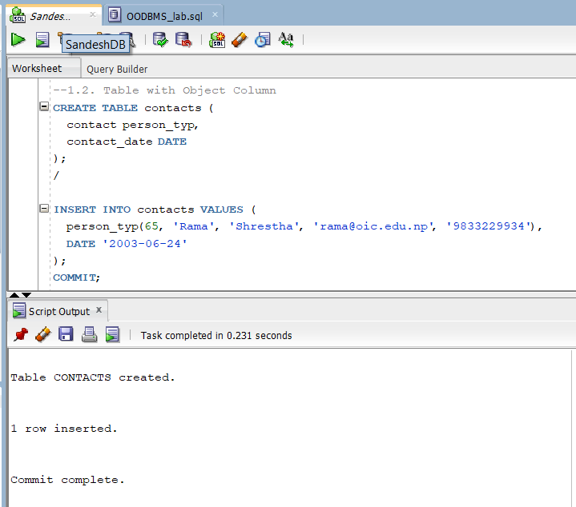

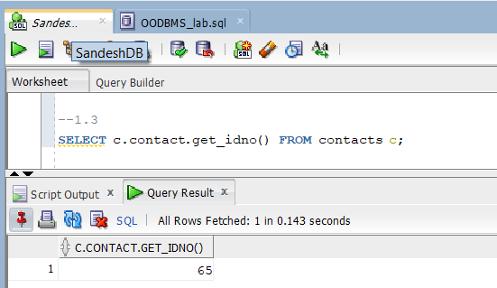

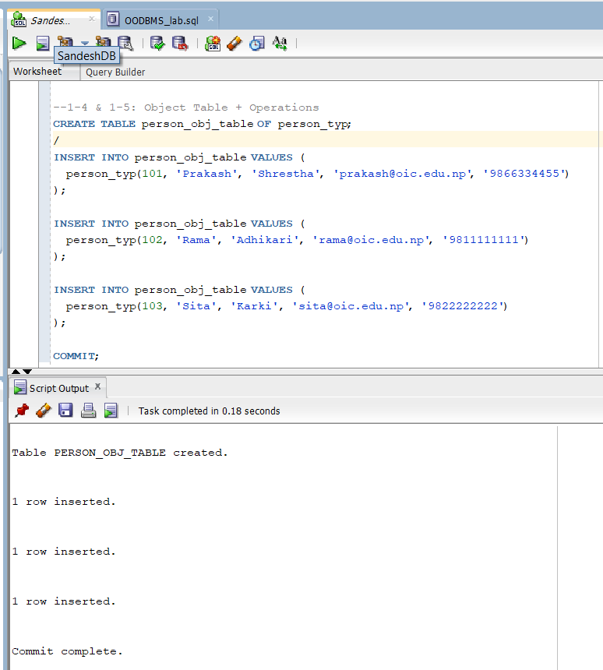
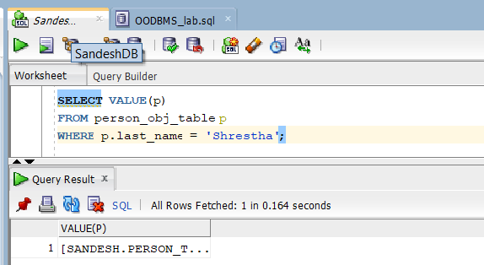
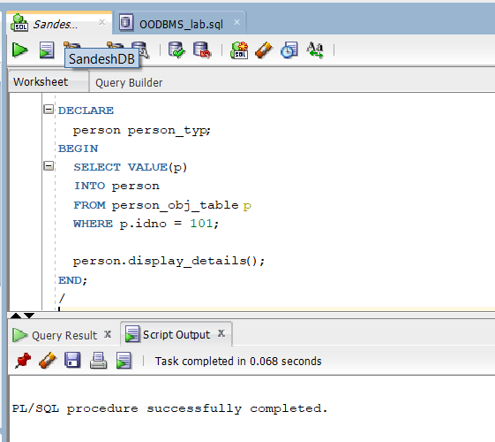
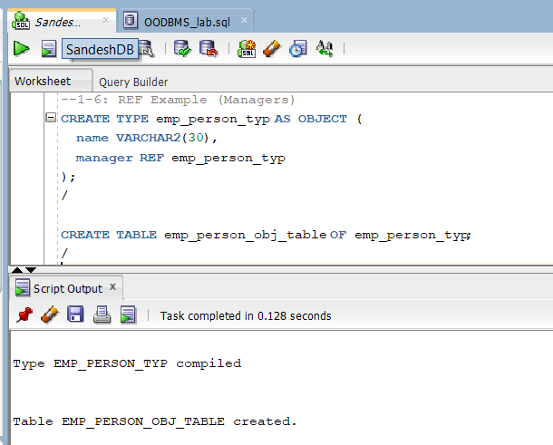
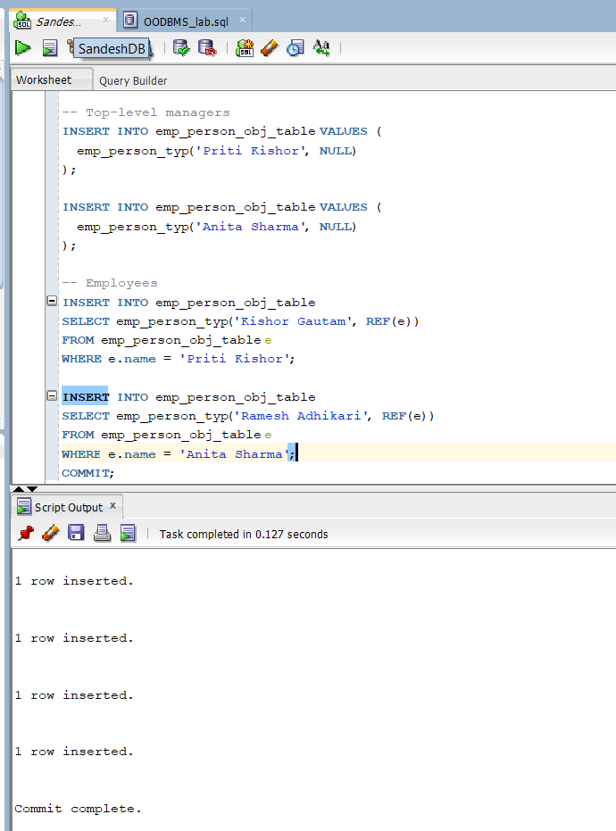
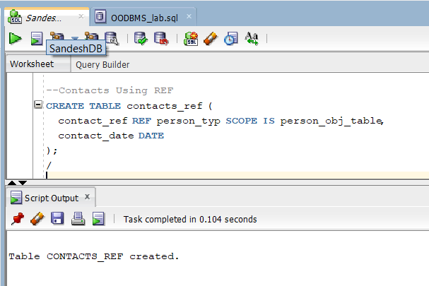
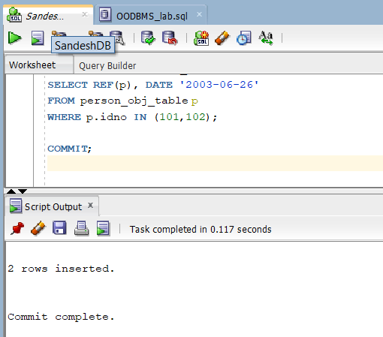
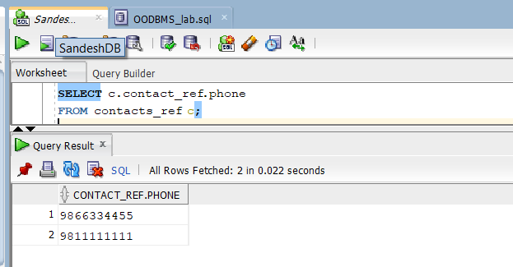
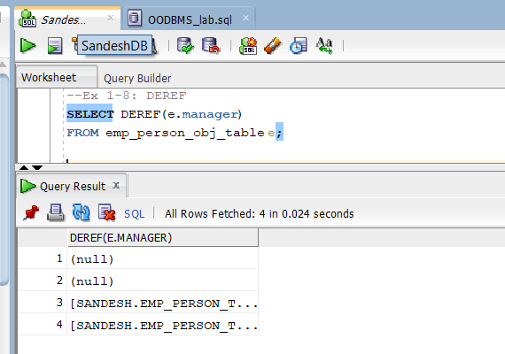
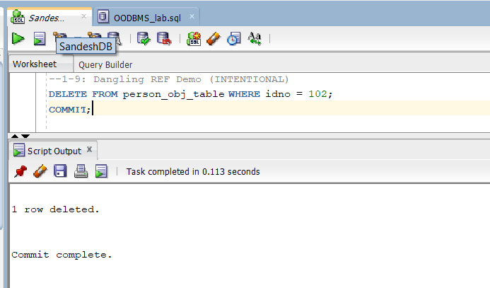
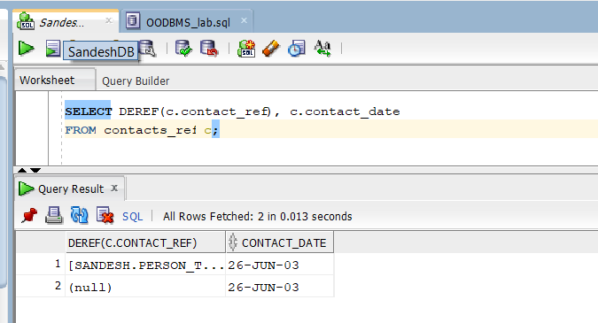
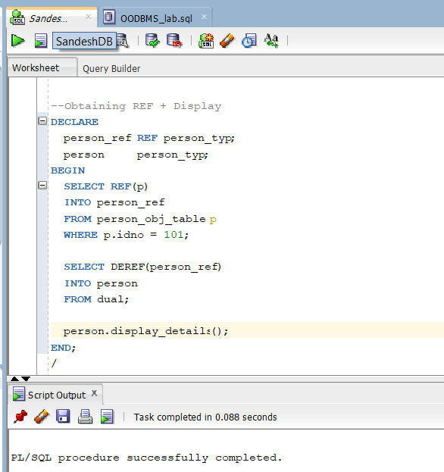
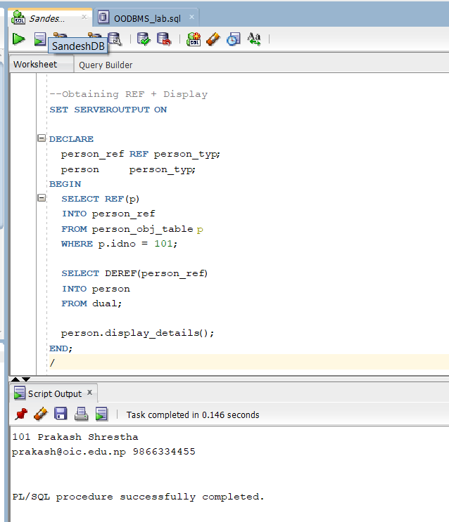

CONCLUSION:
This lab demonstrated Oracle’s object-relational capabilities by combining
relational tables with object-oriented concepts. The use of object types,
methods, and references provided a structured and reusable approach to
data modeling beyond traditional relational design.

